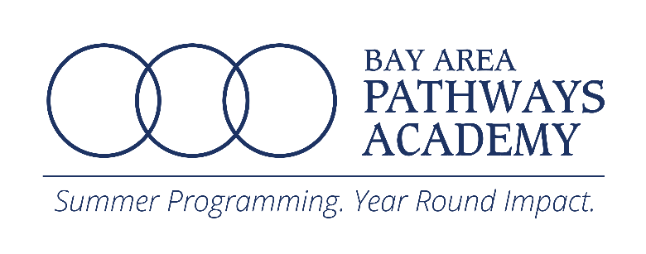

[www.BayAreaPathwaysAcademy.org](http://www.BayAreaPathwaysAcademy.org)

**2023 BAPA Scholarship Application**

* Scholarships are based on financial need and will be provided until scholarship funds are depleted.
* Scholarships may provide partial or full funding for up to one 1-week BAPA session.
* Completed applications* will be reviewed after the deadline in the order that they are received.
* Priority will be given to applicants who have not been awarded scholarships previously.
* **Receipt of a scholarship award does not guarantee the student his or her first choice of classes.**
* You may provide payment to secure your registration; and should you be awarded a scholarship, a refund will be processed.

Applicant Name: Birth date: _____

Address: City/State/Zip:

Has Applicant or Applicant’s sibling attended our summer camp before? YES ___ NO ___

If YES, Name _______________________ Year ____________

Has Applicant been awarded one of our summer camp scholarships before? YES ___ NO ___

If YES, when ________________

Father’s Name: Phone Number: Email:______________

Mother’s Name: Phone Number: Email:______________

Legal Guardian’s Name: Phone Number: Email:______________

Parents’ or Guardians’ Total Monthly Income from:

Wages _____________ Business income __________ Alimony support _____________

Social security/disability benefits __________ Unemployment benefits ______________

Other Government support _____________ Gift/ other form of support _____________

Pension ___________________

If not awarded a scholarship, would you like to complete the registration with a payment?

YES ___ (please return to smccd.edu/bapa to complete your registration). NO ___

I, as the parent or legal guardian of the above-named applicant, attest that the information I have provided is true, current and accurate. I authorize the San Mateo County Community College District’s *BAPA* Program to use my financial statements to consider my child for a scholarship. **I understand that scholarship funds are limited and not all applicants who fall within the Family Income Ceiling will be awarded a scholarship. I have enclosed all requested documents with this application.**

Signature: ___________________________________________ Date: _____________

Printed Name: ________________________________________



**2023 Scholarship Application**

**Steps to Complete Your Application**

Please submit the following with this application:

1. Letter requesting assistance and describing how the applicant is from a household whose income falls within the Family Income Guidelines below.
2. Copy of your 2022 or 2023 federal tax return – IRS Form 1040 including all schedules. (Scholarship Applications will not be accepted without the tax return, with the exception of foster youth applicants).
3. A completed selection of BAPA classes for each period (4 classes per period) & session (6 one week sessions to choose from). Please see the form on the next page.
4. Signed Student Conduct Policy (see page 5) with both parent/guardian and student signatures.

Your application materials must demonstrate that the student is from a household whose income falls below the eligibility guidelines below:

|  |
| --- |
| **SCHEDULE OF INCOME CEILINGS** |
| Family Income Ceilings |

|  |  |  |
| --- | --- | --- |
| **Size of Family Unit** | **Monthly** | **Yearly** |
| **2** | $3,676.05 | $44,110.50 |
| **3** | $4,307.10 | $51,677.85 |
| **4** | $4,938.15 | $59,246.25 |
| **5** | $5,568.15 | $66,813.60 |
| **6** | $6,199.20 | $74,380.95 |
| **7** | $6,829.20 | $81,948.30 |
| **8** | $7,460.25 | $89,515.65 |

Add $573 (monthly) and $6,880 (annually) for each additional family member.

Please return your completed application materials to:

*BAPA/Community, Continuing and Corporate Education*

San Mateo County Community College District

1700 W. Hillsdale Blvd. Bldg. 1, Room 207

San Mateo, CA 94402

**Course Registration for Scholarship Applicants**

BAPA classes run Mon-Fri for 6 one-week sessions, with no limit or minimum for each session options.

**Steps for Selecting Sessions & Classes**

**1.** Select (√) your desired session(s): **Session 1:** 6/19 to 6/30, **Session 2:** 7/3 to 7/14, **Session 3:** 7/17 to 7/28.

**2.** For each One-week session you select, complete class choices in the appropriate chart below. For full day, fill in the boxes for periods 1-8. For half day, fill in the boxes for periods 1-4 (for AM) and 5-8 (for PM). Be sure to include your top 3 choices for each period in case your first or second choice is not available. Visit [www.BayAreaPathwaysAcademy.org](http://www.BayAreaPathwaysAcademy.org) to view course schedules and course descriptions.

**3.** Read and sign the Student Conduct Policy on p.4. You must include parent/guardian & student signatures.

**SAMPLE REGISTRATION: Session 1**

|  |  |  |  |  |  |
| --- | --- | --- | --- | --- | --- |
|  | **AM/PM CLASSES** | | | |  |
|  |  | | | |
|  | **Period 1** | **Period 2** | **Period 3** | **Period 4** |
| **1st Choice** | Math 6 | Spanish Beg 1 |  | Kickboxing |
| **2nd Choice** | Spanish | Social Studies 6 | Intro to Voice | Yoga |
| **3rd Choice** | Creative Writing | Website  Coding I | Pencils & Pastels | Counselor in Training |

**Session 1 Choices**

|  |  |  |  |  |  |
| --- | --- | --- | --- | --- | --- |
|  | **AM CLASSES** | | | |  |
|  | **Period 1** | **Period 2** | **Period 3** | **Period 4** |
| **1st Choice** |  |  |  |  |
| **2nd Choice** |  |  |  |  |
| **3rd Choice** |  |  |  |  |

**Session 2 Choices**

|  |  |  |  |  |  |
| --- | --- | --- | --- | --- | --- |
|  | **AM CLASSES** | | | |  |
|  | **Period 1** | **Period 2** | **Period 3** | **Period 4** |
| **1st Choice** |  |  |  |  |
|  |  |  |  |  |
| **2nd Choice** |  |  |  |  |
| **3rd Choice** |  |  |  |  |

**Session 3 Choices**

|  |  |  |  |  |  |
| --- | --- | --- | --- | --- | --- |
|  | **AM CLASSES** | | | |  |
|  | **Period 1** | **Period 2** | **Period 3** | **Period 4** |
| **1st Choice** |  |  |  |  |
|  |  |  |  |  |
| **2nd Choice** |  |  |  |  |
| **3rd Choice** |  |  |  |  |

**Important Information Before You Complete This Application**

* Emails with important BAPA information will be sent to the email address provided on page 1, so please be sure to provide the correct email address when registering. A separate scholarship application is required for each student.
* BAPA reserves the right to change instructors or classes, if necessary. Classes may not be changed after registration.
* Carefully read and review the Student Conduct and Refund Policies below before completing your registration. **Completion of registration implies parental *and* student agreement with BAPA Student Conduct and Refund Policies.** Please be sure to discuss the conduct policies with each child you register.
* BAPA will not provide summer camp t-shirts for our virtual sessions.

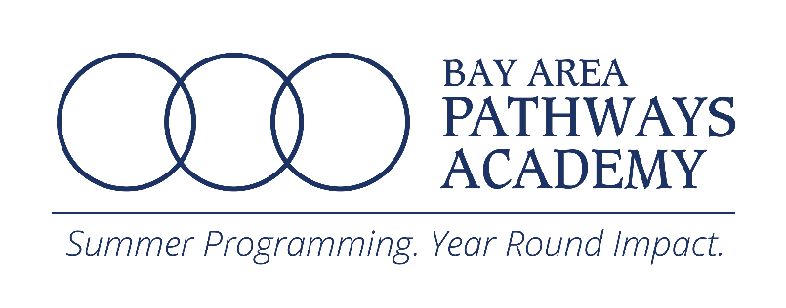

**STUDENT CONDUCT POLICY**

**Proper student conduct is expected the entire time a student is logged on to their classes,**

**from arrival to departure.**

1. I will demonstrate courtesy and respect for all staff members, teachers and students, and will behave in a responsible manner.

2. I will attend my scheduled classes on time unless excused by my parents.

3. I will respect the property of others, including college property and facilities.

4. I will obey all campus and classroom rules, including NO eating, drinking, or gum chewing in classroomsor the use of inappropriate or foul language throughout the entire time I am on campus.

5. I will keep my hands and feet to myself and will not engage in any kind of fighting, threats, or insults.

6. If enrolled in a computer class, I will not download programs nor make any changes to anyprogram or system files, other than those the teacher specifies.

Students who are disruptive will be given the opportunity to correct their behavior before they are removed from the program. Extreme circumstances may require the Site Director to remove a student without warning.

1st time - Student receives a verbal warning.

2nd time - Site Director calls child’s parent/guardian to discuss disruptive behavior.

3rd time - Site Director calls child’s parent/guardian to pick child up immediately. There will be no refund.

The child will be removed permanently from program and will not be able to return.

*I and my child (We) have read and agreed to follow the Student Conduct Policy. We understand that suspension or expulsion may occur if a student willfully or persistently violates any of these rules. We further understand that there will be no refund if a student is expelled from the program. Student may not be allowed to attend future programs.*

______________________ ___/___/2023

**Parent Signature** Month/Day/Year

_____________________ ___/___/2023

**Child Signature** Month/Day/Year

Note: BAPA reserves the right to amend any of its rules and policies and further reserves the right to refuse a student’s registration